Peristaltic pump signal

According to the data (device.xlsx) that we have received from Jenny student of NTHU, we have a 9 different RPM’s (0.1, 0.2, 1, 3, 5, 8, 10, 15, 20 RPM) (RPM stands for rotation per minute). In the file we have 2 sheets (circle and circle block), in my opinion the data from the circle block was very clear to see the peaks and the behavior of the signal in contrast with random data from circle sheet, so I decided to process the data from the second sheet (also you can look at the data in the file plots to see the graphs). Also for the signal processing it was very inconvenient to take 0.2 and 0.5 RPM because there are a few number of peaks on the time domain, which makes data very unclear. The signals ware recorded from 0 second, however, the experimenters were turning pump on after 10 second, which means that first 10 seconds of data are unnecessary. According to this fact was created a new file (DATA_FILE.xlsx), in which the signals were copied from 14.4 second.

Coding part

Since the values of capacitance were very small I have divided every signal into small windows depending on the frequency and subtracted mean value of the window. Then signals were scaled between -1 and +1 to make calculations easier, as we don’t really care about real values of capacitance.

One of the not obvious things is that the peristaltic pump had 4 moving valves, which means that in 1 RPM we got four peaks, this fact will help you to understand the processed data and graphs below.

Peristaltic pump with four moving valves

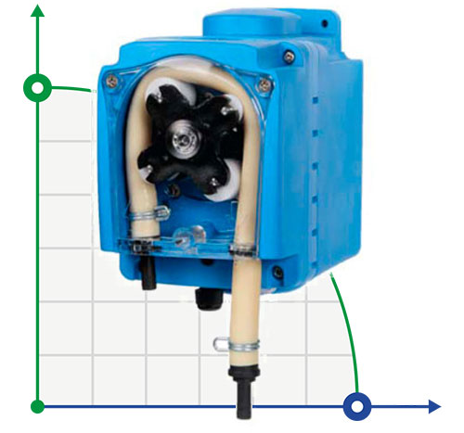

**========================================1RPM========================================**

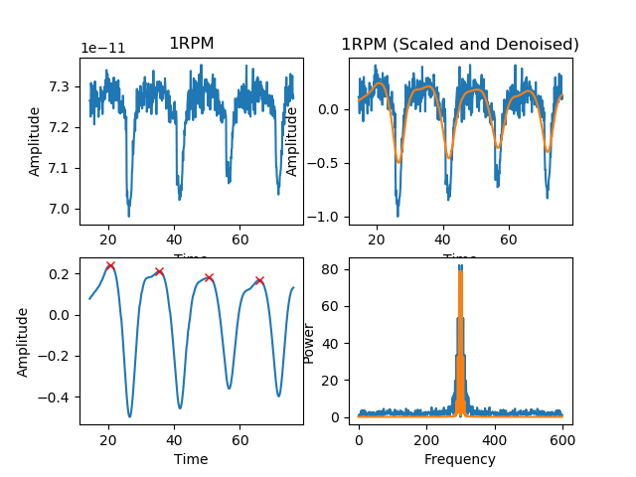

Optimal window is 5.4 seconds

MEAN of 1/4 rotation: 15.066666666666668(sec)

VARIANCE: 0.055555555555556746(sec)

ERROR: 0.0666666666666682(sec)

MEAN of 1/4 rotation: 0.24889380530973448(RPM)

VARIANCE: 0.0009218289085545919(RPM)

ERROR: 0.0011061946902655162(RPM)

Real RPM: 0.9955752212389379(RPM)

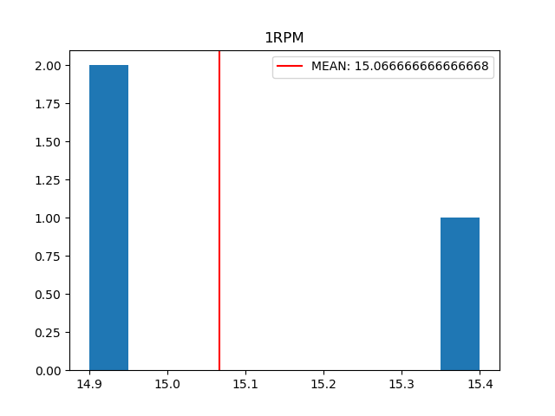

**The histogram shows the number of Δt between the peaks of the current signal on y-axis and time in seconds on x-axis. You can understand it as following -> bins indicate how often the Δt had the same value.**

**========================================3RPM========================================**

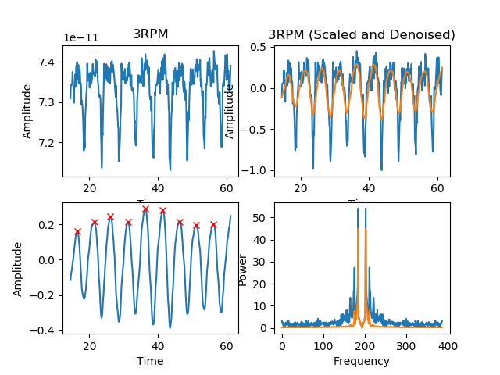

Optimal window is 5.4 seconds

MEAN of 1/4 rotation: 4.9875(sec)

VARIANCE: 0.023593749999999962(sec)

ERROR: 0.012500000000000178(sec)

MEAN of 1/4 rotation: 0.2506265664160401(RPM)

VARIANCE: 0.0011826441102756873(RPM)

ERROR: 0.0006265664160400863(RPM)

Real RPM: 3.0075187969924815(RPM)

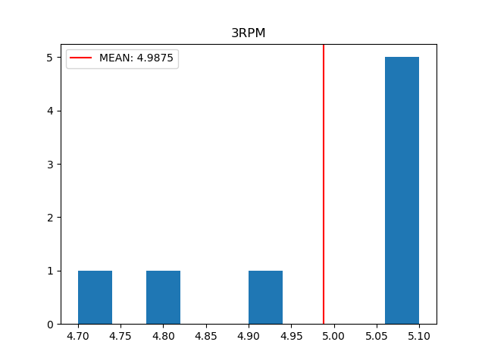

**======================================5RPM==========================================**

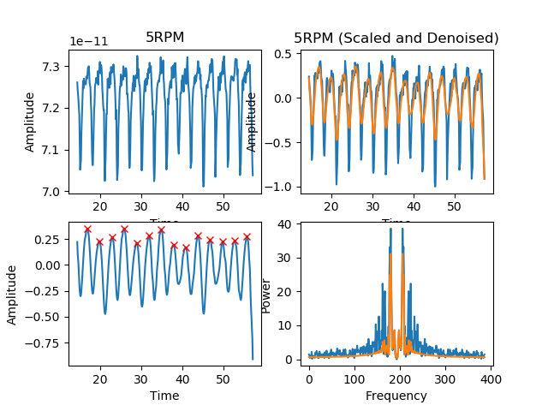

Optimal window is 4.5 seconds

MEAN of 1/4 rotation: 2.9923076923076923(sec)

VARIANCE: 0.006863905325443982(sec)

ERROR: 0.007692307692307665(sec)

MEAN of 1/4 rotation: 0.2506426735218509(RPM)

VARIANCE: 0.0005734625271900499(RPM)

ERROR: 0.0006426735218508783(RPM)

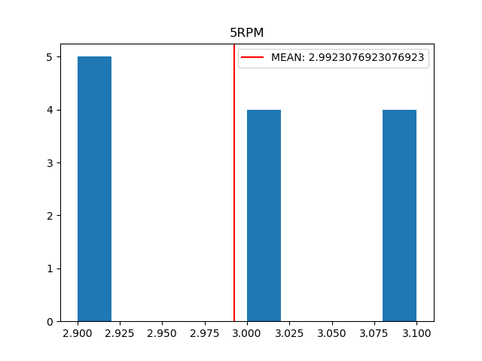Real RPM: 5.012853470437018(RPM)

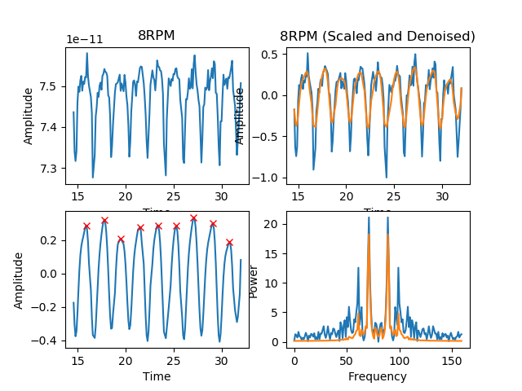**======================================8RPM==========================================**

optimal window is 1.6 sec

MEAN of 1/4 rotation: 1.8625(sec)

VARIANCE: 0.012343750000000056(sec)

ERROR: 0.012499999999999956(sec)

MEAN of 1/4 rotation: 0.25167785234899326(RPM)

VARIANCE: 0.00165687919463088(RPM)

ERROR: 0.0016778523489932584(RPM)

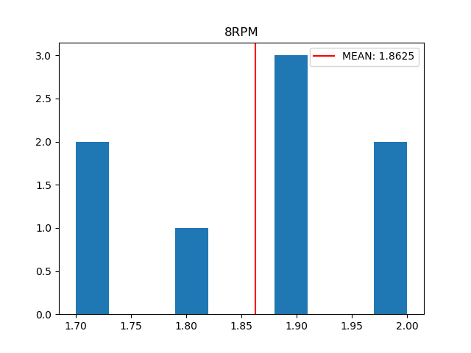Real RPM: 8.053691275167784(RPM)

**======================================10RPM=========================================**

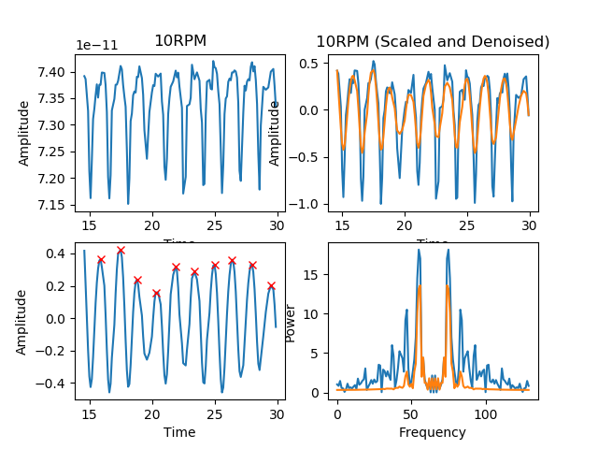

optimal window is 1.4 sec

MEAN of 1/4 rotation: 1.511111111111111(sec)

VARIANCE: 0.009876543209876553(sec)

ERROR: 0.011111111111111072(sec)

MEAN of 1/4 rotation: 0.24816176470588236(RPM)

VARIANCE: 0.001633986928104577(RPM)

ERROR: 0.0018382352941176405(RPM)

Real RPM: 9.926470588235293(RPM)

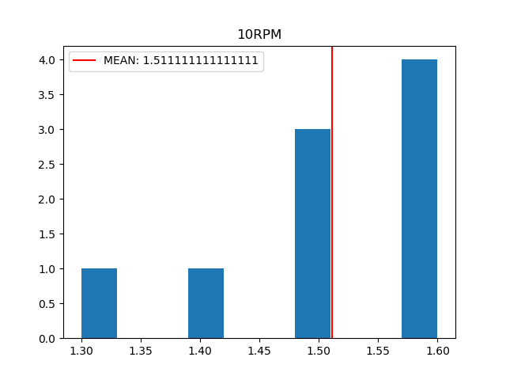

**======================================15RPM=========================================**

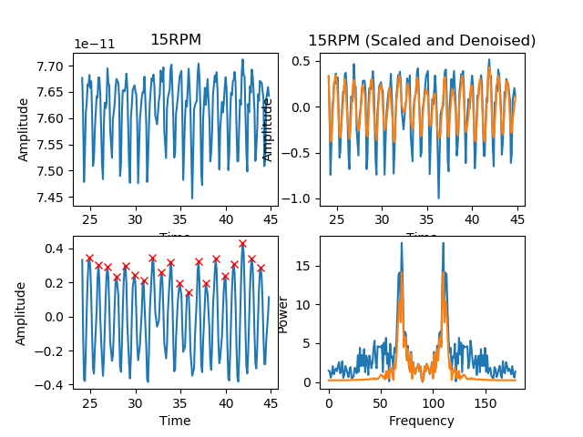

optimal window is 1 sec

MEAN of 1/4 rotation: 1.0(sec)

VARIANCE: 0.0031578947368421954(sec)

ERROR: 0.0(sec)

MEAN of 1/4 rotation: 0.25(RPM)

VARIANCE: 0.0007894736842105488(RPM)

ERROR: 0.0(RPM)

Real RPM: 15.0(RPM)

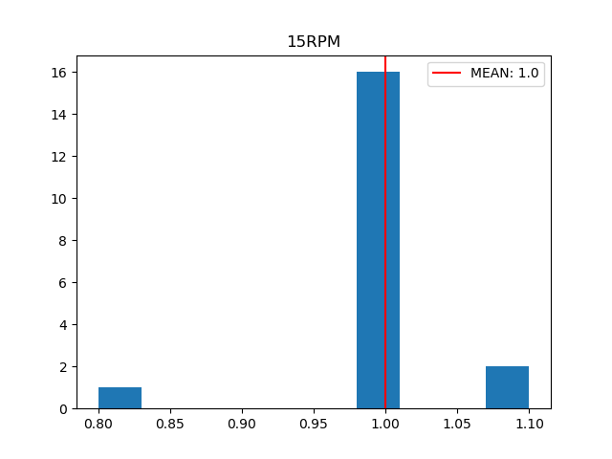

**======================================20RPM=========================================**

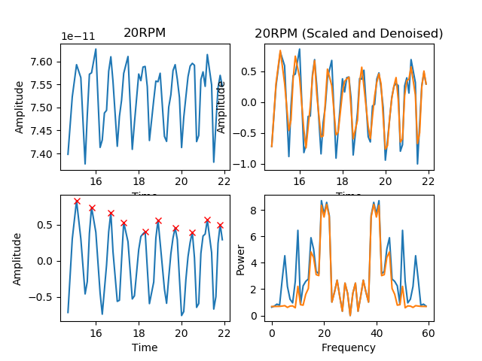

optimal window is 0.6 sec

MEAN of 1/4 rotation: 0.7444444444444446(sec)

VARIANCE: 0.018024691358024633(sec)

ERROR: 0.005555555555555425(sec)

MEAN of 1/4 rotation: 0.251865671641791(RPM)

VARIANCE: 0.00605306799336648(RPM)

ERROR: 0.0018656716417910224(RPM)

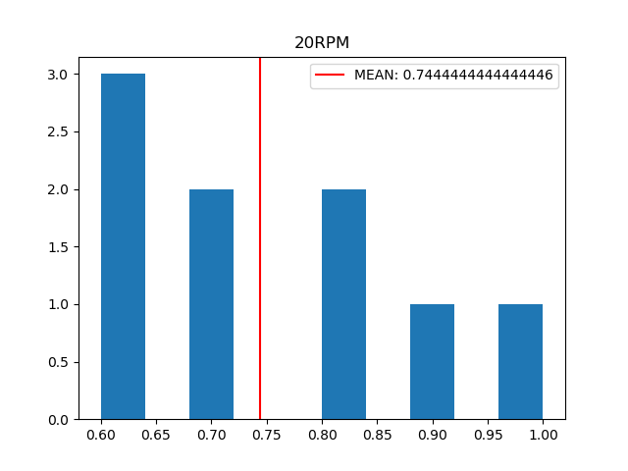

Real RPM: 20.14925373134328(RPM)